Week 12 Practical 12
Topics:
- Design forms to a database
  - Create database ABC_Company.
  - Create table ‘staff’ using design view
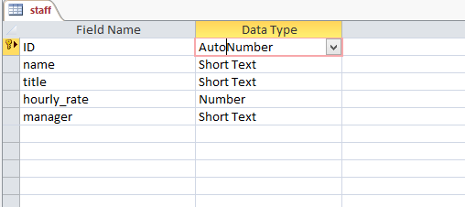

  - Insert following data.
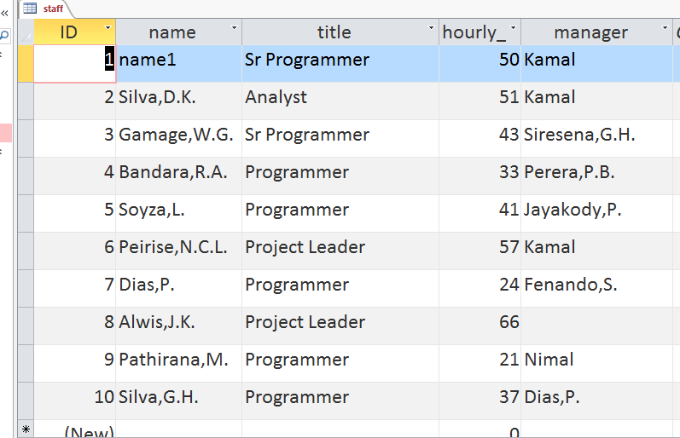

  - Create Form using ‘form’ option.
  - Create form using form wizard.
  - Create form using design view.

